General remarks:

Washes (O) start with a rinse (o). Washes are with 1 mL for 5 minutes for organic solutions and 10 minutes for aqueous solutions unless otherwise indicated. Washes involving hybridization solution are 500 uL. Do not agitate the samples too much during washes, only gently move the liquid in and out of the pipette when removing liquid. Successive washes are done under a running clock. After washes, remove waste from wells in 150 uL increments and with the same 200-uL tip. When washing with the same solution, do not change tips unless you contaminate them. Do not contaminate the pipettes with liquid!!!

Before Day 0: Collect wandering larvae
1. Have the D. guttifera bottle culture (20 bottles a week) on a Tuesday bumping schedule and keep the culture at RT. Collect wandering L3 larvae (start looking for them on Wednesdays) and place them in Petri dish with moist Kleenex on the bottom. Store the Petri dishes in a moist chamber to prevent the animals from drying out. Then wait and wait until the pupae are at the desired stage. Use the poster for stage identification and a magnification of 20 X. Adjust the light source of the microscope so that you see the key characters clearly.

Day 0: Cutting, fixing, and storing pupae

2. Using the blunt forceps (type #2), gently remove the pupae - one at a time - and dry one quickly, using a small piece of Kleenex or Kimwipes. Immediately move the same pupa onto the dissection platform (a glass slide with a piece of double-sided tape on it - see picture below). Move as many pupae as you can - one by one: dry place, dry, place, dry, place, ...) within 2 minutes (time taking from drying the first pupa on Kleenex to putting the last pupa on the tape). Lay the pupae on their belly (dorsal cut) or side (lateral cut). Perform only one type of cut in one session.

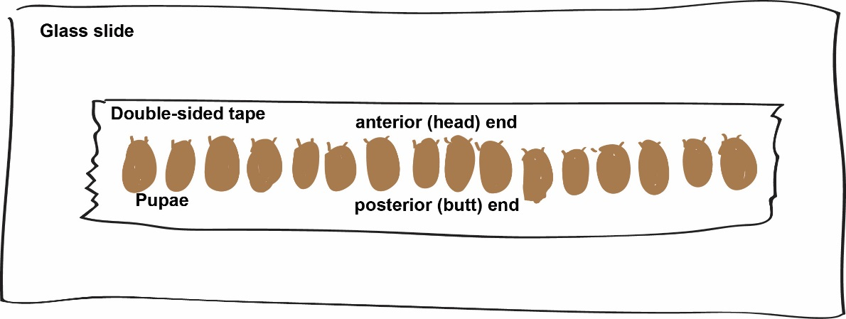

3. With a razor blade, immediately cut each pupa lengthwise (starting with the one first put on the tape). This is best accomplished with a single rapid cut from the anterior to the posterior end of the pupae. Dissect no more than 10 pupae at a time. Practice a lot so that you manage to cut 10 pupae in one session! Label each end of the razor blade and use each end to cut 50 – 60 pupae. Then discard the razor blade in the sharps container (near the sink with the freezer).

4. Using a medium-sized paintbrush, transfer a small amount of 1 X PBS (that you have set aside in a designated 9-well dish well) to each dissected pupa to dissolve them from the tape. A blunt forceps arm (type #2 forceps) may be used to help getting them off the tape.

5. Transfer the pupa halves with the brush into a well (glass viewing dish) filled with 1 X PBS. With a pair of surgical (sharp-pointed) forceps (type #5), grasp an individual pupa half anteriorly (by the head) and
G E N T L Y wash away the internal tissues, using a pipettor set to 8.5 uL (stages P7, P8), 15 uL (stage P9) to 25 uL (P10 and older). Too much pressure or excessive washing WILL lead to the loss of epithelial cells. YOU NEED TO KEEP THE EPITHELIAL LAYER UNDAMAGED (see picture below). Note that you cannot wash away the wings, legs, and gut (if it is attached to the cuticle. Leave them where they are for now and just focus on the soft internal organs.

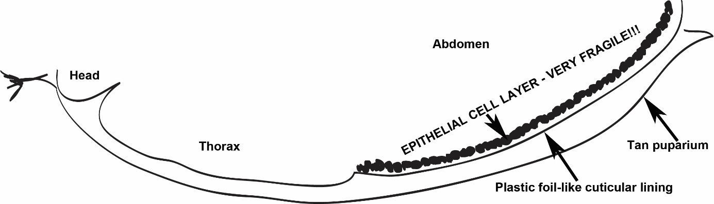

6. Immediately transfer the cleaned pupa halves to a fresh well with 1 X PBS. and store them there until you cut your last pupa (you can cut several rounds of pupae and leave the cleaned carcasses in PBS for up to half an hour. However, 10 pupae are enough per session.

LOOK THROUGH THE MICROSCOPE FOR ALL FOLOWING PIPETTING STEPS WITH THE MICROSCOPE LIGHT ON!!!

Check off the O's and o's so that you know what steps you completed. (When adding liquids, check them off as soon as you added a liquid, not at the end of the respective incubation.)

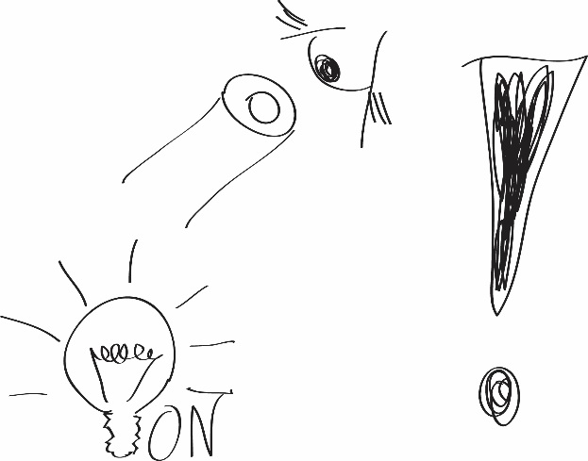

7. Remove the 1 X PBS (look through the microscope at all pipetting steps!) and replace with fixation buffer. Let the samples incubate at room temperature for 1 hour. O

8. Rinse fixed pupae 3 X in 1 X PBS. o o o

9. Samples may immediately be processed for in situ hybridization or may be stored in 100% ethanol at -20°C infinitively. To store samples, equilibrate samples through a dilution series of 1 X PBS:100% ethanol (3:1, 1:1, 1:3) at room temperature for 20 minutes in each dilution. O O O

10. Rinse once, wash once in 100% ethanol, then add 1 mL 100% ethanol, cut a 1-mL tip and transfer the pupae in ethanol into a 2-mL Eppendorf tube for storage at -20ºC. o O----O

CLEAN UP AFTER YOURSELF: MAKE SURE TO DISCARD THE PAPER TOWELS AND CLEAN UP YOUR BENCH (TRASH GOES INTO THE TRASH BIN). WASH GLASS-VIEWING DISHES VERY WELL!

Day 1 (approximately 8 h) RECOMMENDED START = AT 8 AM
Use a dissecting scope to view bodies in a 9-well glass-viewing dish.
ONLY USE 100% (200 proof ethanol, never anything else)

1. Get pupal halves from -20°C O

Transfer the bodies by pipette (using a cut 1 mL tip)

2. Wash 1 X with 100% ethanol O

3. Incubate for 30 minutes in 1:1 xylenes:ethanol (1 mL total) O
Incubate in the hood
discard all xylenes-containing washes in the hood

4. Make sure the big incubator is set to 65°C O

5. Rinse once and wash 5 X with 100% ethanol o O O O O O

6. Equilibrate samples through a dilution series of
1 X PBS:100% ethanol (1:3, 1:1, 3:1)
at room temperature for 20 minutes in each dilution O O O

7. Rinse once and wash 3 X with PBT o O O O

8. Fix for 30 minutes in 1 mL Fix buffer at RT O

In the meantime, get ice (Dow 516 or Dow 704) O

9. Rinse once and wash 5 X with PBT o O O O O O

10. Dilute 1 uL Proteinase K stock [10 mg/mL] in 99 uL PBT
(on ice) O

For each in situ sample, take 4 uL of this dilution and add
it to 1 mL PBT (on ice) O
Proteinase K is dissolved in PBS
Mix Proteinase K well before taking out!
Always keep Proteinase K on ice (bring the stock immediately
back to the freezer)!

11. Replace the last PBT wash with 1 mL proteinase K dilution
(the 1:25,000 dilution from the end of step 10) O

12. Incubate at RT for 10 minutes O

13. Rinse 2 X with PBT o o

14. Wash 2 X with PBT O O

15. Post-fix for 30 minutes in 1 mL Fix buffer at RT O

16. Wash 5 X with PBT o O O O O O

17. Wash in 1:1 PBT:hybridization solution (1 mL) O

18. Wash 3 X in hybridization solution at RT (500 uL) O O O
Move pupae to a 2-mL tube, using a cut 1-mL tip O

19. Turn on dry heating block, set to 80°C O

20. Prehybridize for 1 h in 500 uL hybridization solution at 65°C (incubator) O
Blocking occurs

21. Prepare the probe in a 2-mL tube
Always wear gloves when handling the probe and always keep the probe stock on ice
a. Dilute 1 uL probe in 500 uL hybridization solution O

b. Heat diluted probe 5 minutes in dry block at 80ºC O

c. Put probe on ice (prevents secondary RNA structures) O

22. Replace all hybridization solution with diluted probe (1:500) O

23. Incubate at 65°C for >18 hours, gently swirl periodically O
This is an optional stopping point (2-3 days max)

Day 2 (approximately 4 hrs)
1. Turn on dry heating block at 65°C for pre-warming hyb. solution O

2. Pre-warm 3 mL of hybridization solution per sample at 65°C O

3. Transfer bodies back to a clean glass viewing dish from the tube O
Use a 1-mL pipette with a cut tip

4. Rinse with pre-warmed hybridization solution o

5. Incubate at 65°C for 1 h in pre-warmed (65°C) hybridization solution O

6. Incubate at 65°C 3 X for 30 minutes in pre-warmed (65°C) hybridization solution O O O

Place 750 uL of hybridization solution per sample at RT O
Get Ice O

7. Prepare 1.5 mL of 1:1 PBT:hybridization solution O

8. Wash 2 X with 1:1 PBT: hybridization solution at RT o O O

9. Wash 5 X with PBT o O O O O O

10. Prepare 1:6000 Roche α-DIG AP Fab Fragments O

1,200 uL PBT+0.2 uL Roche α-DIG AP Fab Fragments (on ice!) in a 2-mL tube
11. Pipette the pupae with the 5th PBT wash into a 2-ml tube, using a cut
1-mL pipette tip O

12. Suck out most PBT and plaace pupae on ice
Leave about 50 uL PBT in the tube
O

13. Per in situ sample, add 300 uL of the 1:6000 diluted Roche α-DIG AP Fab Fragments and store the samples at 4ºC overnight O

Day 3 (Approximately 3 hrs [pattern develops within 20 mins to 4+ hours])

1. Wash 5 X with PBT o O O O O O

During the last wash prepare the staining buffer (recipe below)
O

2. Wash 3 X with staining buffer o O O O

During the last wash prepare the staining solution (recipe below)
You will need 400 uL per in situ sample O

3. Remove the epidermis from the pupal case (tan outer shell) O

4. Replace last wash with 0.4 mL of staining solution O

5. Incubate in the dark O

6. Check for the purple pattern every 20 minutes O

7. Stop staining after the pattern looks good: Rinse once and wash 2 X with staining buffer o O O

8. Rinse once and wash 2 X in PBT o O O

PBT (1 L):
100 mL 10 X PBS
900 mL H₂O
1 mL Triton X-100

Fix buffer (40 mL): (Store at 4°C for max. one month)
To a clean 50-mL Falcon tube, add in the following order
4 mL 10 X PBS
85 uL 5 M NaOH about 20 mL sterile distilled H₂O
80 mg Deoxycholic acid
Vortex until the milky color (undissolved deoxycholic acid) disappears
10 mL 16% PFA (1 Paraformaldehyde ampull)
Fill up to 40 mL with sterile distilled H₂O

PBT + Proteinase K (1.5 mL): (Make fresh dilution from frozen stock)
Dilute 1 uL Proteinase K stock [10 mg/mL] in 99 uL PBT (on ice)
For each in situ sample:
Take 4 uL of the 1:99 dilution and add it to 1 mL PBT (on ice)
Discard the 1:99 dilution at the end of the day

Hybridization solution (400 mL): (Store at -20°C)
200 mL Formamide
100 mL 20x SSC
Set pH to 5.5 (check with color strips) and filter sterilize
4 mL Salmon Sperm DNA [10 mg/mL]
40 mg Heparin
400 uL Tween 20
96 mL H₂O

Staining Buffer (50 mL): (Make fresh)
1 mL 5 M NaCl
2.5 mL 1 M MgCl₂
2.5 mL 2 M Tris pH 9.5
50 uL Tween 20
44 mL H₂O

Staining Solution (400 uL): (Make fresh)
400 uL Staining Buffer
2.8 uL NBT (Progema ready-made 50 mg/mL solution; in the freezer)
1.4 uL BCIP (Progema ready-made 50 mg/mL solution; in the fridge)

Basic solutions
100 mL of 2 M Tris pH 9.5: 24.2 g Tris Base
100 mL of 1 M MgCl₂: 20.3 g MgCl₂ * 6 H₂O
100 mL of 5 M NaCl: 29.2 g NaCl
20x SSC see separate protocol

